**Phase 9: Reporting, Dashboards & Security Review**

**➣Reports (Tabular, Summary, Matrix)**

• Tabular Report: Simple list of all Waste Bins and their current fill levels.

• Summary Report: Recycling Records summarized by Citizen to track reward points.

• Matrix Report: Waste collected grouped by Zone (rows) and Material Type (columns).

These help officials analyze waste trends and citizen contributions.

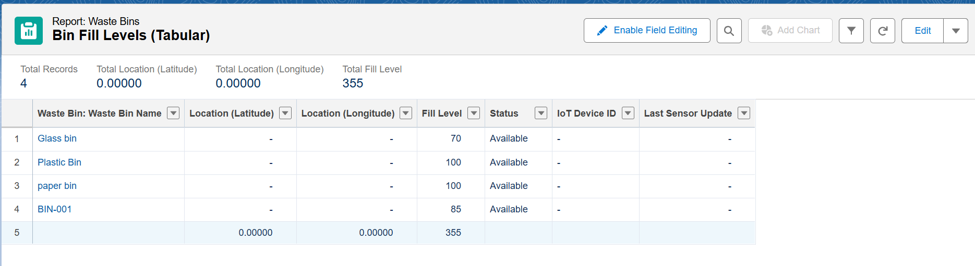

**➣Report Types**

Custom Report Types were created for:

• Pickup Requests with related Bins.

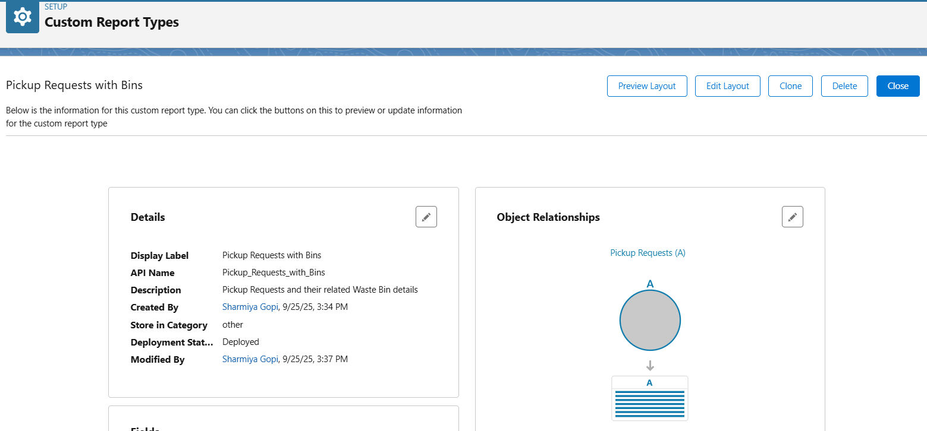

• Recycling Records with related Citizens.

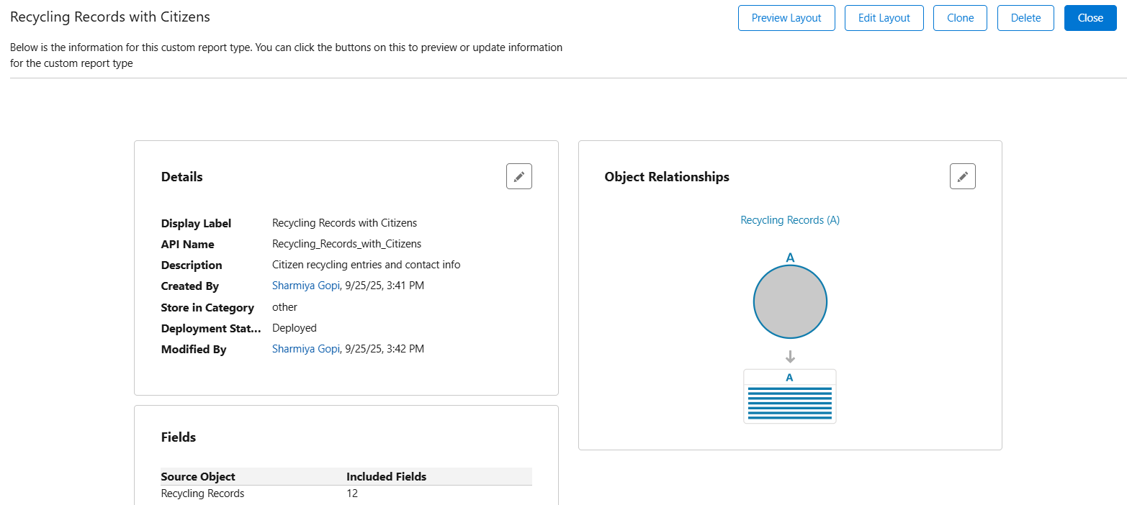

Ensures flexible reporting beyond standard objects.

**➣Dashboards**

Dashboards were built for City Officials:

• Total Waste Collected

• Recycling % Trend (Plastic, Glass, Paper, E-Waste)

• CO₂ Saved (impact visualization)

• Cost Savings from optimized routes

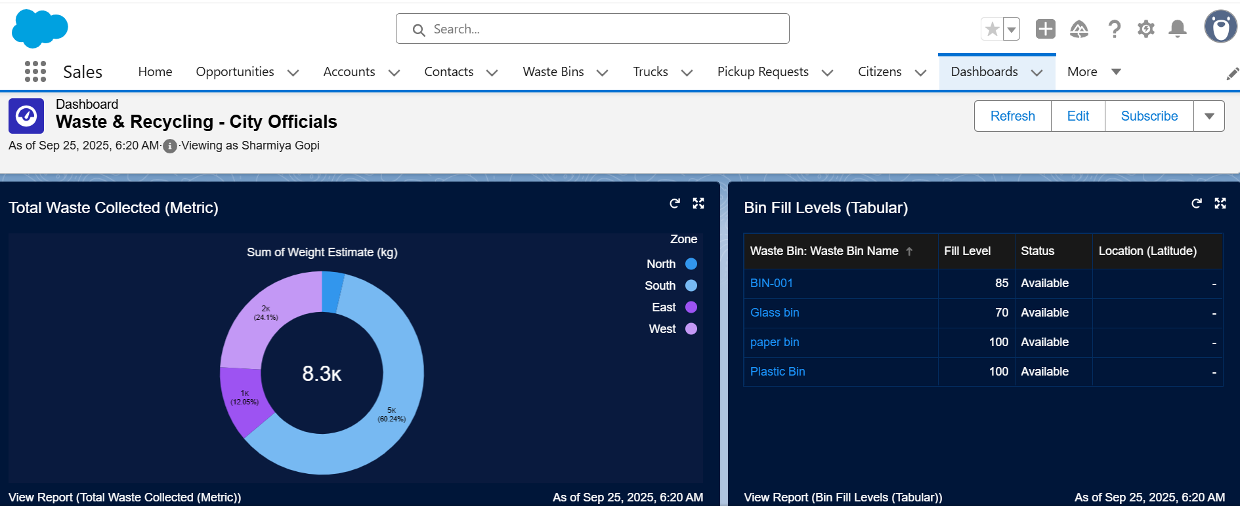

**➣Dynamic Dashboards**

One dashboard served multiple roles:

• City Official sees city-wide recycling rates.

• Truck Driver sees only their assigned pickups.

• Citizen sees their personal recycling contributions (via Portal).

**➣Sharing Settings (OWD + Sharing Rules)**

Enforced least privilege:

• Waste Bin = Public Read/Write

• Truck = Private

• Pickup Request = Private (shared only via rules)

• Citizen = Private

Sharing rules allowed Route Supervisors to see only bins and pickups in their zone.

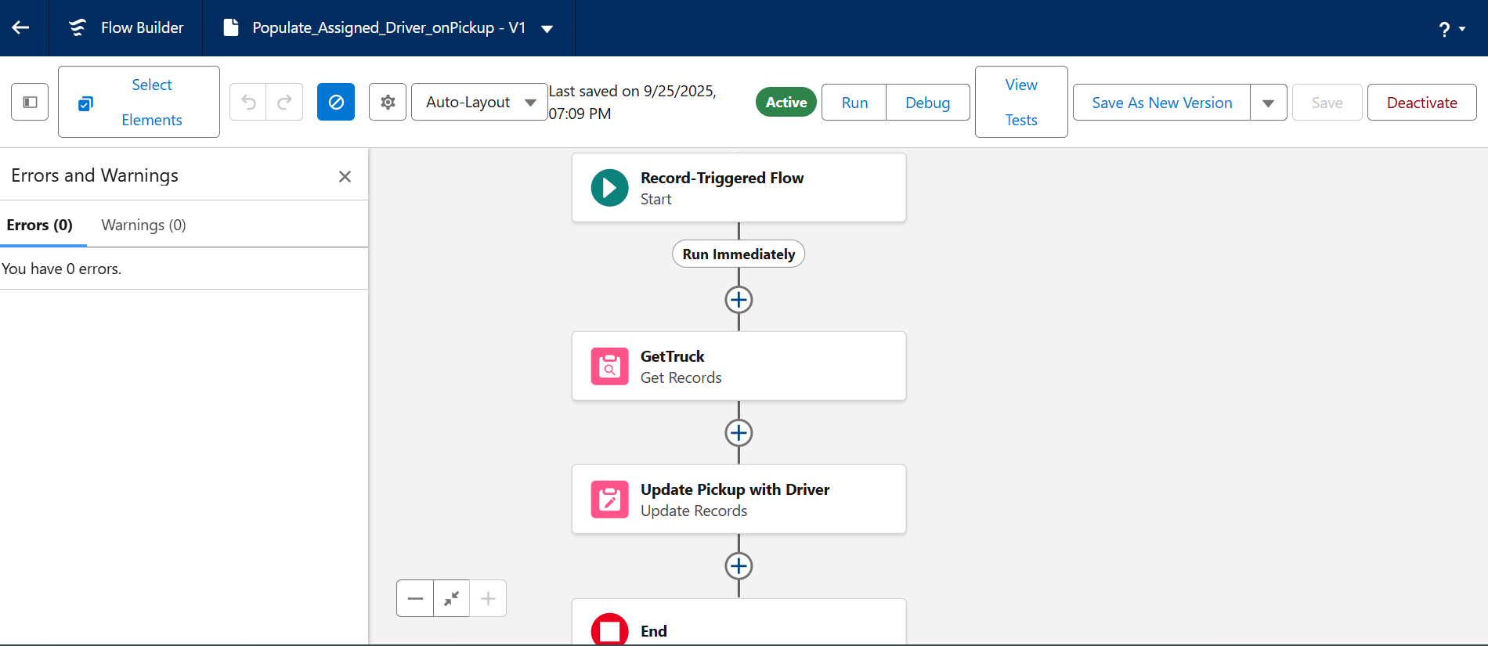

**➣Field Level Security (FLS)**

Controlled sensitive data visibility:

• Drivers can’t edit bin location.

• Citizens can’t see truck details.

• Only officials can see CO₂ savings fields.

**➣Audit Trail**

• Setup Audit Trail was enabled to track config changes (e.g., new fields, sharing changes).

• Ensures accountability in case multiple admins/developers modify org settings.

